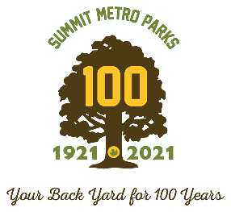

NEWS RELEASE
April 27, 2021
Stephanie Walton Lindsay Smith
Chief of Marketing & Communications Marketing & Public Relations Manager
330-865-8040 x215 330-865-8040 x207
swalton@summitmetroparks.org lsmith@summitmetroparks.org

ENJOY ANNUAL MOTHER’S DAY 5K AS SELF-GUIDED EVENT IN MAY

The Summit Metro Parks Foundation’s popular Mother’s Day 5K is once again available as a self-guided experience in 2021.

“The Mother’s Day 5K is a tradition for Summit Metro Parks and we’re able to offer it this year as a FREE virtual event during this beautiful time of year to come out, enjoy, and support the parks,” said Jen M. Harvey, chief of philanthropy for the park district.

To participate, runners and walkers select their own location and self-report their 5K race time. The run/walk can be completed anytime during the month of May and in any safe location – whether it be in Summit Metro Parks, around the neighborhood or even on a treadmill. To help foster a sense of community, participants will have the opportunity to share their experience with each other on Facebook.
The self-guided event is free with an option to contribute to the Summit Metro Parks Foundation. Visit http://bit.ly/smpMD5K to register online. For more information, please email contact@summitmetroparks.org.

* * * * *
Established in 1921, Summit Metro Parks is celebrating its centennial anniversary in 2021. The park district manages more than 14,000 acres throughout 16 parks, several conservation areas and more than 150 miles of trails, including 22 miles of the Ohio & Erie Canal Towpath Trail. Annual attendance in 2020 was 6 million visits. Visit us online at summitmetroparks.org.

